December 15, 2009

Dear Mr. Chair and members of the committee:

Over the past 14 years, 13 states have removed state criminal penalties from the physician-recommended medical use of marijuana. SB 368 and its companion bill, AB 554, are commonsense and humane bills that reflect the experiences learned from medical marijuana laws in Alaska, California, Colorado, Hawaii, Maine, Michigan, Montana, Nevada, New Mexico, Oregon, Rhode Island, Vermont, and Washington.

There is strong support among medical and legal organizations for protecting seriously ill patients from arrest. Among other organizations, respected medical organizations such as the American College of Physicians, the American Nurses Association, the Leukemia & Lymphoma Society, and the American Academy of HIV Medicine all support allowing seriously ill patients to use medical marijuana. The American Bar Association also supports medical use of marijuana. Support for medical marijuana is also found in Wisconsin-specific medical organizations. The Wisconsin Nurses Association and the Wisconsin Public Health Association have supported legal, medical use of marijuana since the beginning of the decade.

Mirroring the support found in the medical and legal organizations, there is strong public support for allowing the medical use of marijuana on both the national level and within individual states. A CNN/Time magazine national poll, published on November 4, 2002, found that 80% of those polled support legal access to medical marijuana. There is also overwhelming support for medical marijuana within Wisconsin. A 2005 poll found 75.7% support for allowing “people with cancer, multiple sclerosis, and other serious illnesses to use marijuana for medical purposes, so long as their physician approves.”

Because current state medical marijuana laws are working well and protecting terribly ill patients, they are all incredibly popular in practice. In 2006, polls done in each of the 11 states with medical marijuana laws at that time found public support for the medical marijuana laws ranging from 59% to 79%. None of the state laws that passed by initiative had lower support than when they passed.

These medical marijuana laws have provided near total protection for terminally and seriously ill patients: 99% of all marijuana arrests are by state and local — not federal — officials. Furthermore, as of October 19, 2009, the Department of Justice has advised United States district attorneys not to use “federal resources in ... States on individuals whose actions are in clear and unambiguous compliance with existing state laws providing for the medical use of

marijuana.” This policy shift creates a space for states to allow well-regulated access to medical marijuana without fear of federal interference. Because of this change in federal policy, SB 368 would ensure that Wisconsin’s seriously ill patients will not only be protected from arrest and prosecution for using their medicine, but that they will also have safe and legal access to the medicine their doctors recommend.

Part of the reason the laws are so popular is that the problems that some predicted did not materialize: Teens’ marijuana use has not increased in any of the medical marijuana states since their laws passed. In many cases, it has decreased substantially. For example, the Youth Risk Behavior Survey found that high school students’ current marijuana use dropped by 30% in Hawaii. In Nevada, high schoolers’ current marijuana use has dropped by 33% since its law passed.

Most concerns about medical marijuana laws have surrounded California’s law. But even there, the problems are not widespread, as evidenced by the fact that the law has 72% public support. California’s medical marijuana initiative was the first law of its kind, and it consisted of only eight sentences. The concerns about it have stemmed from aspects of the law that differ from Wisconsin’s bill.

The biggest concern regarding California’s law is the lack of regulation of dispensaries. Although several California cities and counties are enacting ordinances to regulate dispensaries, many cities have not yet done so, and the state law provides no real regulation for them. Unlike Wisconsin’s bill, California’s law also does not include any provisions for licensing of dispensaries.

Dispensaries fill a very significant void that many state medical marijuana laws leave. They can provide seeds and small starter plants or “cuttings” to patients and their caregivers to get them started. They also provide medicine to patients who wouldn’t be able to wait several months to grow plants to a harvestable size. Perhaps most importantly, they can immediately provide medicine to patients who are suddenly stricken with an illness or who cannot grow their own medicine (and have no one who will). Patients would also benefit greatly from having the option of buying medicine if they suffer a crop failure or their plants under-produce. For the aforementioned reasons, the recent trend in state medical marijuana laws has been to include provisions for the licensing of dispensaries. Within the past year, three states (New Mexico, Rhode Island, and Maine) have licensed dispensaries or passed laws amending their existing medical marijuana laws to allow for them.

While dispensaries are a very important aspect of ensuring safe access to medical marijuana, they are not enough without also allowing patients and their caregivers to cultivate their own medicine. Many patients will be disabled, unable to work, and facing other steep costs for medical care. Many patients would probably begin by buying a few cuttings or some seeds to start out, but will simply not be able to afford to continually buy their medicine from dispensaries. By allowing personal cultivation, Wisconsin’s bill assures that patients of limited means will be able to grow their own medicine.

The amount of marijuana that patients and their caregivers are allowed to grow and possess under SB 368 and AB 554 — 12 live marijuana plants and three ounces of usable marijuana — is in line with the amount of marijuana currently allowed under most state medical marijuana laws. For instance, states such as Michigan and Rhode Island allow patients to possess 12 plants and 2.5 ounces of useable marijuana. After hearing out patients, experts, and law enforcement, the Washington State Department of Health set their state’s limit at 15 plants and 24 ounces, after determining that that amount constituted a 60-day supply. Although somewhat conservative, SB 368’s limit would likely be sufficient for most patients who solely cultivate their own medicine without supplementing it from dispensaries.

Wisconsin’s medical marijuana bills — SB 368 and AB 554 — are good legislation that will provide relief for the seriously ill. I hope that the committee will pass SB 368, to provide relief to seriously ill patients who are currently facing arrest for relieving their suffering.

Sincerely,

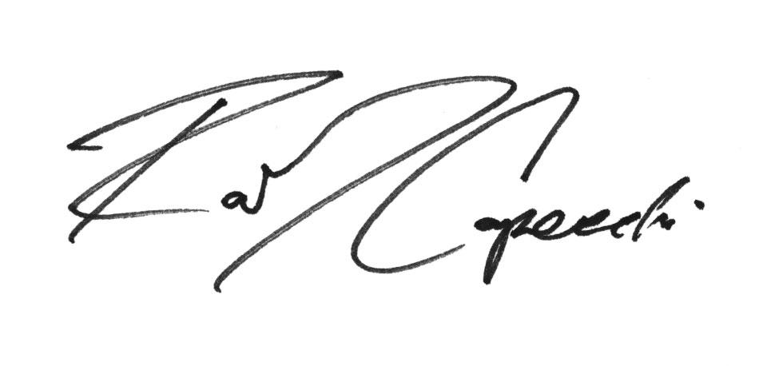
Robert J. Capecchi
Legislative Analyst, State Policies
Marijuana Policy Project
(202) 462-5747, ext. 2007
rcapecchi@mpp.org

State-By-State Medical Marijuana Laws: How to Remove the Threat of Arrest, Marijuana Policy Project, 2008. Appendix P.
Id. at Appendix P - 15
3 Id. at D – 1.
4 “Proposition 215 Ten Years Later: Medical Marijuana Goes Mainstream,” November 2006, <http://www.mpp.org/prop215>.
5 See FBI Uniform Crime Reports 2003 (U.S. Government Printing Office), p. 269, Table 4.1 and p. 270, Table 29 and Compendium of Federal Justice Statistics (Bureau of Justice Statistics), p. 13, Figure 1.1. Calculations derived from the two cited Uniform Crime Reports tables show that there were a total of 755,186 marijuana arrests nationwide during 2002. The Compendium of Federal Justice Statistics table states that there were 8,299 arrests for federal marijuana offenses in the 12-month period ending on September 30, 2003. Thus the arrests for federal marijuana charges are 1.09% of the total marijuana arrests.
David W. Ogden, Deputy Attorney General of the United States. Memorandum For Selected United States Attorneys on Investigations and Prosecutions in States Authorizing the Medical Use of Marijuana. October 19, 2009
Karen O’Keefe and Mitch Earleywine, PhD, “Marijuana Use by Young People: The Impact of State Medical Marijuana Laws.” (When the report was released, before-and-after data was only available for eight of the medical marijuana states. Since then, additional government data has been released showing that teen use has also decreased since Montana and Vermont’s medical marijuana laws passed.) <http://www.mpp.org/teens>
National Center for Chronic Disease Prevention and Health Promotion, “Hawaii Youth Risk Behavior Survey 1999”; “Hawaii Youth Risk Behavior Survey 2005”; breakdowns available at <http://apps.nccd.cdc.gov/yrbss/SelQuestyear.asp?cat=3&desc=Alcohol%20and%20Other%20Drug%20Use&loc=HI>.
National Center for Chronic Disease Prevention and Health Promotion, “Nevada Youth Risk Behavior Survey 1999”; “Nevada Youth Risk Behavior Survey 2005”; breakdowns available at < http://apps.nccd.cdc.gov/yrbss/SelQuestyear.asp?cat=3&desc=Alcohol%20and%20Other%20Drug%20Use&loc=NV>.
Mason-Dixon Polling & Research, Inc., September 2006 (a poll of 625 likely voters in California).
California Health and Safety Code 11362.5.

